Sep-16-2020 (EL Suncrops Citrus-001) ARM 2020.1 Site Description
Estelle Louw
Evaluate the effect of Suncrops Plus for Sunburn control in citrus.
Trial ID: | EL Suncrops Citrus-001 | Location: | Hoedspruit | Trial Year: | 2019
Protocol ID: | Suncrops Citrus | Investigator: | Estelle Louw
Project ID: |  | Study Director: | Thys van Lingen
 |  | Sponsor Contact: | Wenkem SA

General Trial Information
Study Director: | Thys van Lingen | Title: | Mr.
Investigator: | Estelle Louw | Title: | Ms

Discipline: | P | growth regulator (plant)
Trial Status: | F | one-year/final |  |  |  | Trial Reliability: | HIGH |  | high quality
ARM Trial Created On: | Sep-16-2020
Initiation Date: | Nov-8-2019
Completion Date: | Jul-21-2020

Trial Location
City: | Hoedspruit |  | Country: | ZAF | South Africa
State/Prov.: | Limpopo
Postal Code: | 1380 | Climate Zone: |  | BSh |  | Arid Steppe Hot

Latitude of LL Corner: | -24°24,090' |  | S
Longitude of LL Corner: | 30°51,085' |  | E
Altitude of LL Corner: | 510,00 | m

Conducted Under GLP: | No
Conducted Under GEP: | Yes

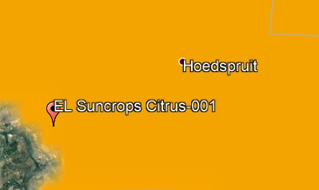

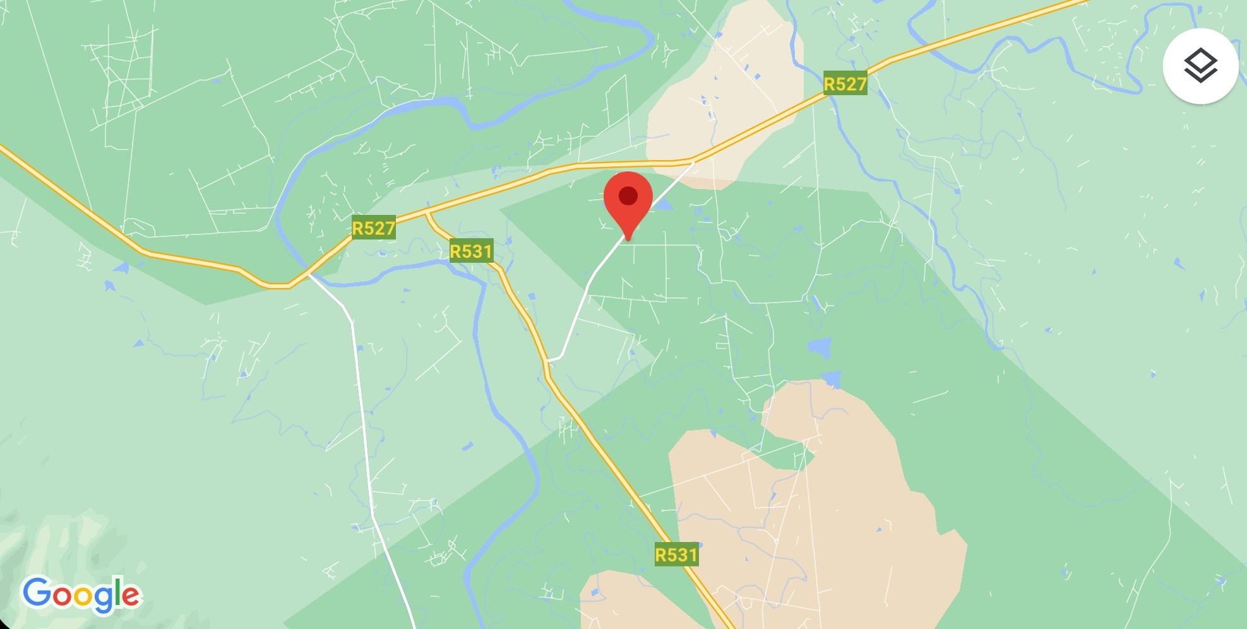

Sep-16-2020 (EL Suncrops Citrus-001) ARM 2020.1 Site Description
Estelle Louw
Evaluate the effect of Suncrops Plus for Sunburn control in citrus.
Trial ID: | EL Suncrops Citrus-001 | Location: | Hoedspruit | Trial Year: | 2019
Protocol ID: | Suncrops Citrus | Investigator: | Estelle Louw
Project ID: |  | Study Director: | Thys van Lingen
 |  | Sponsor Contact: | Wenkem SA

Objectives:

Evaluate the effect of Suncrops Plus for Sunburn control in citrus.

Introduction:

A trial was conducted in a (soft skin) citrus orchard, in block G60 (var. IRM2 (Low seeded Murcott mandarin)), on the farm Grovedale (Blydevallei Mariepskop Estate), which is situated just outside of Hoedspruit (Maruleng municipal district) in the Limpopo Province of South Africa. The cultivar chosen for study purposes is known to exhibit (severe) symptoms of sunburn damage. Climatic conditions were generally favourable for the duration of the trial and had no prominent adverse impact on the data obtained in this study. The citrus trees selected for trial purposes were generally in a good condition and overall stress free.

Material and Methods:

The trial was laid out in a block design (block application) for ease of application. Each treatment plot consisted of nine (9) consecutive (subsequent) trees within a single tree row (see Trial Map). The first and last tree in each treatment plot were used as buffer trees in order to negate the impact of spray drift between subsequently placed treatment plots, effectively rendering 7 trees for evaluation purposes. Each treatment plot comprised a total surface area of 135m² (2.5m (tree spacing) x 6m (row spacing) = 15m² x 9 trees).

The trial commenced, with the first application for treatments 1 – 4, 7 and 8, on 08/11/2019, after fruit set, i.e. with fruit from the first (out-of-season) set already about 30% - 60% final size, but with fruit from the second (main) fruit set between 5% and 20% final size. Since the majority of the trees exceeded 3m in size, i.e. 2.7m - 3.7m tree height and 2.3m – 3.3m canopy width (see Application Description), the product(s) were applied at 12.5kg/ha for the reduced application rate, and 25.0kg/ha for the proposed application rate (see Treatment List below). The adjuvant Picanta was added to all the treatments, at an application rate of 30ml/100L water, so as to enhance adhesion of the product onto the fruit skin. An untreated control was also included in the trial.

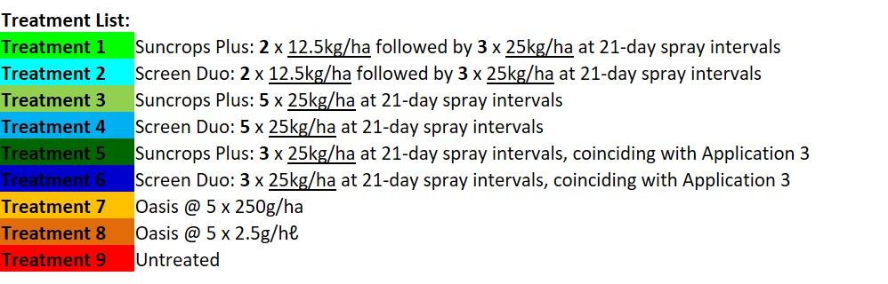

For treatments 1 – 4, 7 and 8, four (4) more applications were applied at approximately 21-day intervals, i.e. 29/11/2019 (21DAA1), 20/12/2019 (21DAA2), 13/01/2020 (24DAA3 (rain delayed)), and 03/02/2020 (21DAA4). Strict adherence to spray intervals depended on weather conditions (wind and/or rain), and/or site accessibility.The first two foliar applications for treatments 1 and 2 were done at the reduced application rate, i.e. 12.5kg/ha, with the last three (3) applications applied at the proposed (max.) rate of 25kg/ha. This was done so as to reduce application (product) costs. The foliar applications for Treatments 5 & 6 commenced on 20/12/2019 only, and was, in all instances, applied at the proposed (max.) rate of 25kg/ha. The reduced application treatment, i.e. applying only during peak (summer) season (Treatments 5 & 6), was also included so as to determine whether the efficacy would prove sufficient so as to reduce the number of applications, i.e. application costs.

The foliar applications were done with a vehicle mounted, high pressure orchard sprayer at a constant pressure of 15bar, with a hand-held spray gun containing an adjustable 3.5mm cone nozzle. The handgun was adjusted in order to obtain a medium to full cover spray cover i.e. between 1800 and 2500ℓ/ha depending on tree height and foliar density (Figs. 1 - 3). This was done not only for effective fruit coverage, i.e. to reduce sunburn damage on the fruit skin, but to also effectively cover the whole of the tree, i.e. so as to reduce stress when temperatures increased and/or when high heat situations persisted. Agitation prior to application occurred by inserting the handgun tip into the applicable 50ℓ plastic tank containing the spray mix, i.e. by directing (propelling) the spray jet into the spray solution. This was done for approximately 20 seconds so as to ensure proper agitation, i.e. to properly dissolve (mix) the product(s) in the spray water. Agitation during application was obtained by inserting a (double) set of spray pipes, connected to a diaphragm pump, into the spray water. Motor driven (Kohler 3000 Series 6.5hp 196cc), constant and/or consistent circulation was obtained as unused spray water (mix), sucked in through the intake pipe, was redeposited into the spray tank through the outlet pipe (re-directed back-flow) so as to keep the product(s) in suspension. Agitation during application was sufficient so as to ensure that the product(s) remained in suspension. The Wettable Powders were weighed off on a MICRO NHB-6000 (S/N: 3816171052; Cap = 6 000g; d = 0.1g)) field scale, dissolving the product in approximately 8ℓ of spray water, within a durable plastic bucket. The dissolved product(s) was added to approx. 20ℓto the spray water, where after the spray tank(s) were filled to capacity, i.e. 50ℓ.
Sep-16-2020 (EL Suncrops Citrus-001) ARM 2020.1 Site Description
Estelle Louw
Evaluate the effect of Suncrops Plus for Sunburn control in citrus.
Trial ID: | EL Suncrops Citrus-001 | Location: | Hoedspruit | Trial Year: | 2019
Protocol ID: | Suncrops Citrus | Investigator: | Estelle Louw
Project ID: |  | Study Director: | Thys van Lingen
 |  | Sponsor Contact: | Wenkem SA

In each instance, the Wettable Powder(s) was added to the spray water first, followed by the adjuvant. No physical compatibility problems such as separation, and/or excessive foaming, was observed for any of the products for the duration of the trial. Sedimentation, however, did occur readily when the product(s) were not kept in suspension. This not only stresses the need for proper agitation during application, but would also necessitate immediate rinsing after application so as to ensure proper cleaning of the spraying apparatus. In each instance, prior to application, the pH of two (2) separate water tanks, containing 50ℓ of spray water, was determined with a HM Digital PH-80 pH meter, while the Electrical Conductivity (EC in µS/cm) and Total Dissolved Salts (TDS in ppm) was determined with a HM Digital COM-80 TDS/EC meter.

Two efficacy assessments were done, i.e. at 24 DAA-C (Days After Application C) (13/01/2020) and 21 DAA-D (03/02/2020). The assessments were done by determining the extent of sunburn damage on the fruit skin (peel) of the fruit on the western tree sides, for the trees planted roughly from north to south, since sunburn damage tends to be more excessive on the western tree side(s) due to the higher (UV) radiance in the afternoon. Sunburn severity was determined using a (damage) rating scale, i.e. where 0 = Clean, 1 = Negligible, 2 = Slight, 3 = Moderate, 4 = Severe, and 5 = Excessive (Fig. 4). Incidences of sunburn damage was determined by counting the number of fruit per plot with sunburn damage (PESINC), irrespective of the severity of the sunburn damage. With each assessment, a total number of 35 fruit per replication was inspected for sunburn damage, rendering a total of 175 fruit per treatment for evaluation purposes, i.e. 35 fruit x 5 replications (trees). Percentages, i.e. increase and reduction, was calculated in all instances using Abbott’s formula, i.e. (±)(N_{untreated} – N_{treated}) ÷ N_{untreated}.

At the time of the commercial harvest, at 169 DAA-E (21/07/2020), all the fruit were removed by hand and placed in plastic crates (lug boxes) to be weighed on a STS-QAL (Cap. = 100kg, d = 0.01kg, S/N: AL-6-2-4-0872) field scale. The yield obtained with each treatment was determined, thereafter, as the average mass (kg) per tree. Although all nine (9) data trees were harvested, only five (5) trees (replications) were used for assessment purposes, i.e. those trees with the highest yield(s). The first (1st) and last trees were discarded as sprayed buffer trees, i.e. to negate the impact of spray drift, while an additional two (2) trees were discarded so as to negate the impact of smaller trees, and/or trees with a poor set, i.e. to negate outliers (variations) that could impact on the reliability of the data obtained.

For each treatment, a single crate (lug box) filled with fruit, i.e. ≥ 50 fruit with a mass ≥ 20kg, was collected, at the time of the commercial harvest, for a post-harvest assessment. The fruit were transported to the office (residence) of the trialist for storage and assessment. The fruit were kept outside, at ambient temperatures, for a period of 10 days to enhance maturation and/or disease development. No diseases were noted at the time of the assessment on 31/07/2020. The post-harvest assessment encompassed determining the average mass per fruit (MICRO NHB-6000 field scale (S/N: 3816171052; Cap = 6 000g; d = 0.1g)), the average fruit diameter (Electronic Digital Calliper (ISO9001:2000 (300 x 0.01mm / 12” 1960)), the fruit firmness (Model GY-3 Penetrometer (S/N: X001OB6Y3R; Cap. 12kg/cm²; d = 0.1 / Cap. 24kg/cm²; d = 0.2)), and the sugar content (SPER SCIENTIFIC 300010 Sugar/Brix Refractometer (0 – 32% w/ATC)).

Results and Discussion:
All of the treatments investigated reduced the severity of sunburn damage statistically significantly when compared to the untreated control, at both 24DAA3 / 1 (24 DAA-C) (Table 1) and at 21DAA4 / 2 (21 DAA-D) (Table 2), i.e. when using the average sunburn (rating) index as parameter. No further assessment(s) on sunburn damage was conducted as the onset of external discolouration, towards the end of the citrus growing season, hampered reliable (effective) distinction between sunburn damage symptoms and natural fruit discolouration.

Suncrops Plus compared overall very well with the standard treatment, Screen Duo (Figs. 7 – 12). A slight numerical advantage was obtained with Treatment 5 (Reduced Application Treatment: 3 x Suncrops Plus @ 25kg/ha), over Treatment 6 (3 x Screen Duo @ 25kg/ha), at 24DAA3 (24 DAA-C) (Tables 1 & 3), most notably w.r.t. the number of clean (sunburn damage free) fruit (Fig. 7), and sunburn damage incidences (Fig. 9). This could have related to trial variation and/or error, i.e. fruit bearing and/or the number of out-of-season fruit (longer exposure time). At 21DAA4 (21 DAA-D), however, these differences proved statistically significant w.r.t. both the severity (Table 2), and incidences (Table 4), of sunburn damage (Figs. 10 – 12), which could have indicated product advantages. Suncrops Plus numerically outcompeted Screen Duo w.r.t. the yields obtained with each of the different treatment plans (Fig.13), although this proved to have been statistically insignificantly so (Table 5). The least promising results were obtained with Oasis, when applied either per hectare, or per hectolitre.

Although the severity indices proved statistically insignificant at 24DAA3 / 1 (24 DAA-C) (Table 1) and 21DAA4 / 2 (21 DAA-D) (Table 2), the full (complete) spray programme, i.e. 5 x Suncrops Plus @ 25kg/ha at 21-day intervals, did slightly outcompete the other treatment plans at 24DAA3 / 1, i.e. the reduced application rate treatment (Treatment 1), and the reduced application treatment (Treatment 5). This treatment yielded numerically the highest number of clean fruit, i.e. on average 29.6 out of 35 fruit (127.7% increase in export quality fruit) (Fig. 7), the lowest number of waste fruit, i.e. on average 0.4 out of 35 fruit (91.7% reduction of category 4 – 5 fruit) (Fig. 8), and the lowest number of fruit containing with sunburn damage, i.e. on average 14.9 out of 35 fruit (75.7% reduction in sunburn damage incidences) (Fig. 9). This indicated a slight increase in sunburn damage when reducing the initial application rate, i.e. when commencing with 2 x Suncrops Plus @ 12.5kg/ha (Treatment 1), or a prominent increase in sunburn damage when reducing the number of applications, i.e. commencing with the applications late(r) in the citrus growing season (Treatment 5).
Sep-16-2020 (EL Suncrops Citrus-001) ARM 2020.1 Site Description
Estelle Louw
Evaluate the effect of Suncrops Plus for Sunburn control in citrus.
Trial ID: | EL Suncrops Citrus-001 | Location: | Hoedspruit | Trial Year: | 2019
Protocol ID: | Suncrops Citrus | Investigator: | Estelle Louw
Project ID: |  | Study Director: | Thys van Lingen
 |  | Sponsor Contact: | Wenkem SA

At 21DAA4 (21 DAA-D) (Tables 3 & 4), the full (complete) programme numerically (Treatment 3) still slightly outcompeted the reduced application rate programme (Treatment 1) w.r.t. the number of clean fruit, i.e. on average 23.6 fruit (168.2% increase) vs. 21.4 fruit (143.2% increase) (Fig. 10), the number of severely affected fruit, i.e. on average 0 fruit (100% reduction) vs. 0.4 fruit (77.8% reduction) (Fig. 11), and sunburn damage incidences, i.e. on average 29.7 fruit (58.7% reduction) vs. 36.0 fruit (50.0% reduction) (Fig. 12). The complete spray programme (Treatment 3) numerically outcompeted the reduced application rate treatment (Treatment 1) w.r.t. the yield obtained (Table 5), i.e. 96.0kg/tree vs. 81.0kg/tree (Fig. 13), suggesting that 5 x Suncrops Plus @ 25kg/ha might ultimately prove more cost effective. It might, however, prove feasible to investigate commencing with 2 x Suncrops Plus @ 25kg/ha applications, followed by 3 x Suncrops Plus @ 12.5kg/ha applications, so as to enhance (compound) the initial impact obtained, when aiming to reduce application costs.

This statement, however, seems to be negated by the slight numerical advantage obtained with the reduced application treatment (Treatment 5), at 21DAA4 / 2 (21 DAA-D) (Tables 3 & 4), w.r.t. the number of clean fruit, i.e. 24.4 fruit (177.3% increase) vs. 23.6 fruit (168.2% increase) (Fig. 10), and sunburn damage incidences, i.e. 28.0 fruit (61.1% reduction) vs. 29.7 fruit (58.7% reduction) (Fig. 12), while a comparative value was obtained w.r.t. the number of waste fruit, i.e.0 fruit (100% reduction) (Fig. 11). The reason for this could have related to trial variation and/or error, i.e. difficulties in distinguishing between sunburn damage and external discolouration, or could have related to pre-mature (drop) weaning of fruit with severe sunburn damage. The latter, however, was not noticeably reflected by the yields obtained (Table 5), i.e. with Treatment 3 yielding an average fruit mass of 96.0kg/tree (60.0% increase resulting in a 24.0 ton/ha yield increase), compared to the 96.4kg/tree (60.6% increase resulting in a 24.2 ton/ha yield increase) obtained with Treatment 5 (Fig. 13). Treatment 5 (reduced application treatment) did yield slightly bigger fruit, i.e. with an average fruit mass of 163.1g (Fig. 14), and an average fruit diameter of 72.3mm (Fig. 15).

The full (complete) spray programme (Treatment 3) yielded numerically, on average, the smallest fruit, i.e. with an average fruit mass of 147.4g (Fig. 14), and an average diameter of 69.5mm (Fig. 15), which might be preferred by consumers. Treatment 3, most importantly, yielded (numerically) the least variation in fruit sizes, as was indicated by the Range (difference between the highest value and the lowest value), w.r.t. to both the fruit mass, i.e. 104.2g (Fig. 14), and the fruit diameter, i.e. 20.3mm (Fig. 15). The impact of the complete (full) spray programme (Treatment 3) might prove more prominent on yield when commencing with the applications with or just after fruit set, in order to negate heat stress on fruit set so as to promote fruit retention, rather than commencing later, as was the case with this study, so as to ensure effective cover (protection) up to the end of summer, i.e. up to the end of February. Application intervals could be extended to 28 days so as to extent the effective protection period. It might then also prove feasible to compare the reduced application treatment (Treatment 5) to the full spray programme (Treatment 3), when commencing simultaneously so as to enhance (compound) the initial impact on sunburn damage, and applying at 28-day spray intervals so as to extent the effective coverage (protection) period.

All of the treatments investigated apparently reduced the fruit firmness, i.e. as was indicated by reduced the densimeter reading obtained with the penetrometer (Fig. 16). This could have indicated an increase in the fruit maturation (ripeness) with the treatments applied, i.e. softer fruit, or it could have related to fruit sizes, i.e. with smaller fruit tending to be sweeter (personal observations). All of the treatments did yield fruit sizes slightly smaller than that obtained with the untreated control (Fig. 14), while rendering a slightly, to prominently, higher brix percentage (sugar content) than did the untreated control (Fig. 17). However, with (extensive) corky internal tissue prominently present, for the untreated control fruit, where sunburn damage occurred (Fig. 5), this is most probably the reason for the apparent reduction in the firmness of the treated fruit.

For the Suncrops Plus treated fruit, the full spray programme (Treatment 3) yielded the highest densimeter reading, i.e. 45.3kg/cm² (Fig. 16), indicating the probability of a (slightly) longer shelf life. At the same time, this treatment yielded the highest brix, i.e. 16.5% (Fig. 17), indicating the sweetest (most mature) fruit.

No physical compatibility problems such as separation, and/or foaming, were noted for any of the compounds for the duration of the study, proving ease of use. Sedimentation, however, did occur readily when the product(s) were not kept in suspension. No phytotoxicity symptoms were noted, on either the foliage or the fruit, for any of the treatments investigated, proving the treatments safe to use in citrus orchards as specified. With the pre-harvest assessment, a wet cloth was used to clean the sampled fruit. All of the remnant product proved easily removable by hand (Fig. 6), indicating that clean fruit can be obtained in the pack house, i.e. with the treatments found not to have impacted adversely on fruit quality.

Conclusions:

All of the treatments investigated reduced the severity of sunburn damage statistically significantly when compared to the untreated control. Suncrops Plus compared overall very well with the standard treatment, Screen Duo. A slight numerical advantage was obtained with Treatment 5 (Reduced Application Treatment: 3 x Suncrops Plus @ 25kg/ha), over Treatment 6 (3 x Screen Duo @ 25kg/ha), at 24DAA3. This proved statistically significant, w.r.t. to both severity and incidences, at 21DAA4. Suncrops Plus numerically outcompeted Screen Duo w.r.t. the yields obtained with each of the different treatment plans, although this proved to have been statistically insignificantly so. The least promising results were obtained with Oasis, when applied either per hectare, or per hectolitre.

Sep-16-2020 (EL Suncrops Citrus-001) ARM 2020.1 Site Description
Estelle Louw
Evaluate the effect of Suncrops Plus for Sunburn control in citrus.
Trial ID: | EL Suncrops Citrus-001 | Location: | Hoedspruit | Trial Year: | 2019
Protocol ID: | Suncrops Citrus | Investigator: | Estelle Louw
Project ID: |  | Study Director: | Thys van Lingen
 |  | Sponsor Contact: | Wenkem SA

The full (complete) spray programme (Treatment 3), i.e. 5 x Suncrops Plus @ 25kg/ha at 21-day intervals, slightly outcompeted the other treatment plans at 24DAA3 / 1, yielding (numerically) the highest number of clean fruit, the lowest number of waste fruit, and the lowest number of fruit containing with sunburn damage. This indicated a slight increase in sunburn damage when reducing the initial application rate, i.e. when commencing with 2 x Suncrops Plus @ 12.5kg/ha (Treatment 1), or a prominent increase in sunburn damage when reducing the number of applications, i.e. commencing with the applications late(r) in the citrus growing season (Treatment 5).

At 21DAA4 (21 DAA-D), Treatment 3 still slightly outcompeted Treatment 1 w.r.t. the number of clean fruit, the number of severely affected fruit, sunburn damage incidences, and yield, suggesting the 5 x Suncrops Plus @ 25kg/ha to be slightly more cost effective. It might, however, prove feasible to investigate commencing with 2 x Suncrops Plus @ 25kg/ha applications, followed by 3 x Suncrops Plus @ 12.5kg/ha applications, so as to enhance (compound) the initial impact obtained, when aiming to reduce application costs.

This statement, however, seems to be negated by the comparative values obtained with Treatments 3 and 5. This could have related to trial variation and/or error, i.e. difficulties in distinguishing between sunburn damage and external discolouration, or pre-mature fruit drop of fruit with severe sunburn damage. The latter, however, was not reflected by the yields obtained. Treatment 5 did yield slightly bigger fruit, which could have contributed to the mass per tree ultimately obtained.

Treatment 3 did yield smaller fruit, which might be preferred by consumers, while yielding the least variation in fruit sizes. The impact of Treatment 3 might prove more prominent on yield when commencing with applications at the time of fruit set, i.e. promoting fruit retention, rather than commencing later, i.e. ensuring protection up to the end of summer (February). Application intervals could then be extended to 28 days so as to extent the effective protection period. It might also prove feasible to investigate the efficacy of Treatment 5 when commencing at the same time so as to enhance (compound) the initial impact of sunburn damage, again extending the spray intervals to 28 days so as to prolong the effective protection period.

All of the treatments apparently reduced fruit firmness. This, could have indicated an increase in the fruit maturation (ripeness) with the treatments applied, i.e. softer fruit, or it could have related to fruit sizes, i.e. with smaller fruit tending to be sweeter. However, although all of the treatments did yield smaller fruit sizes, while yielding a higher sugar content, the firmer untreated fruit most probably related to the (extensive) internal corky tissue present where sunburn damage occurred.
For the Suncrops Plus treated fruit, Treatment 3 did yield the firmer fruit, indicating the probability of a (slightly) longer shelf life. At the same time, this treatment yielded the highest sugar content, indicating the sweetest fruit.

No physical compatibility problems such as separation, and/or foaming, were noted for any of the compounds for the duration of the study. Sedimentation occurred readily when the product(s) were not kept in suspension, necessitating proper agitation during application, as well as proper cleansing of the spray apparatus afterwards. No phytotoxicity symptoms were noted for any of the treatments investigated, proving these treatments safe to use in citrus orchards as specified. For all the treatments, the remnant product proved easily removable by hand, indicating that the treatments did not impacted adversely on fruit quality.

Sep-16-2020 (EL Suncrops Citrus-001) ARM 2020.1 Site Description
Estelle Louw
Evaluate the effect of Suncrops Plus for Sunburn control in citrus.
Trial ID: | EL Suncrops Citrus-001 | Location: | Hoedspruit | Trial Year: | 2019
Protocol ID: | Suncrops Citrus | Investigator: | Estelle Louw
Project ID: |  | Study Director: | Thys van Lingen
 |  | Sponsor Contact: | Wenkem SA

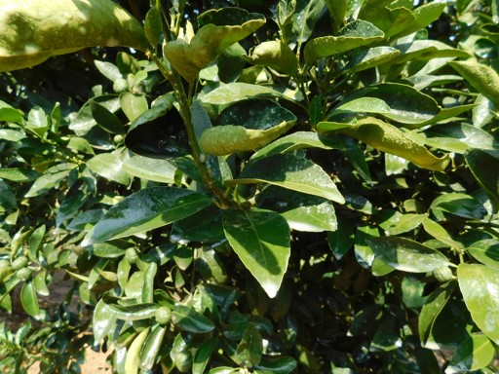
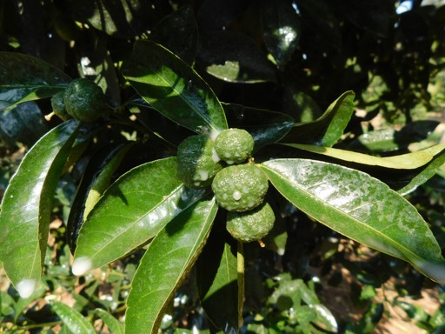

Fig. 1 Spray coverage of the foliage (left) and fruit (right).

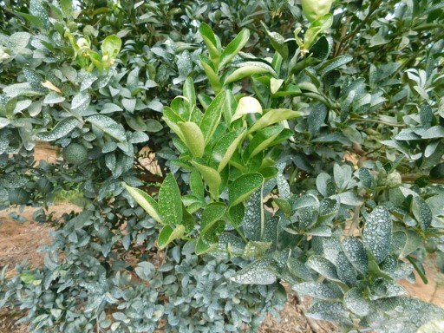
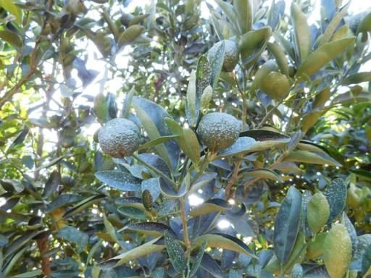

Fig. 2 Product adhesion onto the foliage (left) and fruit (right) prior to the 3^{d} application.

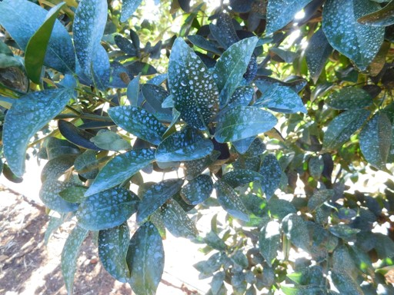
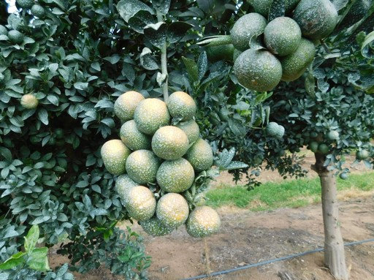

Fig. 3 Product adhesion onto the foliage (left) and fruit (right) prior to the last (5th) application.

Sep-16-2020 (EL Suncrops Citrus-001) ARM 2020.1 Site Description
Estelle Louw
Evaluate the effect of Suncrops Plus for Sunburn control in citrus.
Trial ID: | EL Suncrops Citrus-001 | Location: | Hoedspruit | Trial Year: | 2019
Protocol ID: | Suncrops Citrus | Investigator: | Estelle Louw
Project ID: |  | Study Director: | Thys van Lingen
 |  | Sponsor Contact: | Wenkem SA

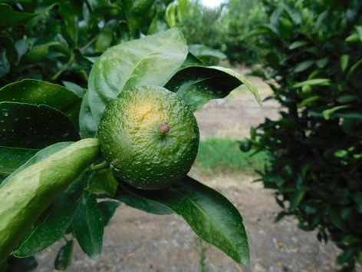
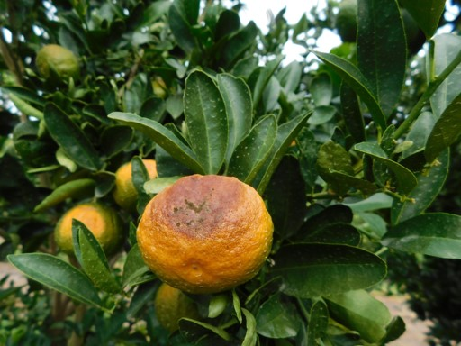

Fig. 4 Slight (left), i.e. rating 1, to severe (right), i.e. rating 5, sunburn damage.

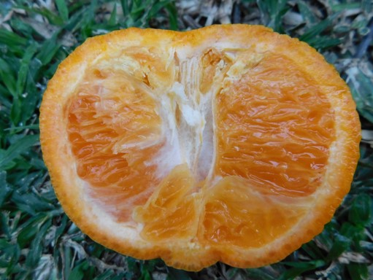
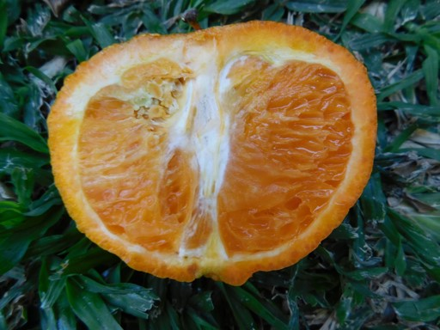

Fig. 5 Slight (left) to severe (right) signs of internal sunburn damage.

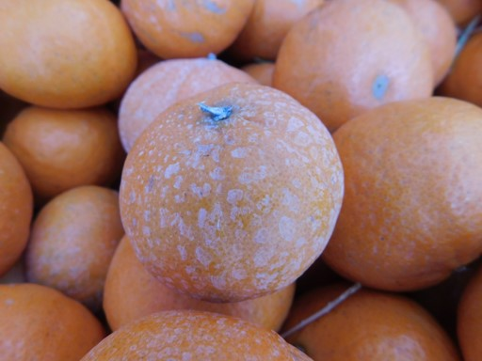
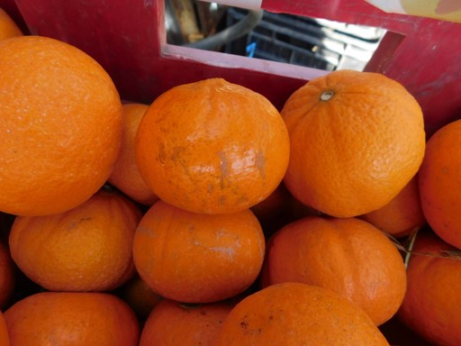

Fig. 6 Harvested fruit prior to cleansing (left), and after (right), proving ease of removal of the coating.

Sep-16-2020 (EL Suncrops Citrus-001) ARM 2020.1 Site Description
Estelle Louw
Evaluate the effect of Suncrops Plus for Sunburn control in citrus.
Trial ID: | EL Suncrops Citrus-001 | Location: | Hoedspruit | Trial Year: | 2019
Protocol ID: | Suncrops Citrus | Investigator: | Estelle Louw
Project ID: |  | Study Director: | Thys van Lingen
 |  | Sponsor Contact: | Wenkem SA

Contacts
Study Director: | Thys van Lingen |  | Title: | Mr.
Organization: | Wenkem SA
 |  |  |  | Phone No.: | 0123453201
 |  |  |  | Mobile No.: | 0662666109
 |  |  | E-mail: | thys.vanlingen@wenkem.co.za
Country: | ZAF | South Africa

Investigator: | Estelle Louw |  | Title: | Ms
Organization: | Agricultural Researcher - RD Agric Pty (Ltd)
Address: | PO Box 1591 / 94 Maree Street
City+State/Prov: | Hoedspruit / Kampersrus |  |  | Mobile No.: | 0843194559
Postal Code: | 1380 / 1371 |  | E-mail: | c.estelle.Louw@gmail.com
Country: | ZAF | South Africa

Co-operator/Landowner
Co-operator: | Pieter Scholtz |  | Role: | FALDOW
Organization: | Blydevallei Mariepskop Estate
City: | Hoedspruit
State/Prov: | Limpopo
Postal Code: | 1380 |  | Mobile No.: | 0832637137
Country: | ZAF | South Africa | E-mail: | pieter@blydevallei.co.za

Crop Description
Crop 1: | C | CIDSS | Citrus sp. |  |  |  | Citrus
Entry Date: |  |  | Sep-16-2020 |  |  |  | Stage Scale: | BBCH
Variety: |  |  | IRM2
Planting Date: |  |  | Mar-6-2014
 |  |  |  |  |  |  | Planting Density: | 666 |  | P/ha
Row Spacing: |  |  | 6 | m
Spacing within Row: |  |  | 2,5 | m
Harvest Date: |  |  | Jul-21-2020

Pest Description
Common Name: | Sunburn | Entry Date: | Sep-16-2020

Site and Design
Treated Plot Width: | 6 | m |  |  |  |  | Site Type: | ORCHAR |  | orchard
Treated Plot Length: | 2,5 | m |  |  |  |  | Experimental Unit: | 1 | PLOT |  | plot
Treated Plot Area: | 15 |  | m2 | Treatments: | 9 |  | Block | : | G60
Replications: | 5 |  |  |  |  |  | Study Design: | BLOCK |  | Block Application

Sep-16-2020 (EL Suncrops Citrus-001) ARM 2020.1 Site Description
Estelle Louw
Evaluate the effect of Suncrops Plus for Sunburn control in citrus.
Trial ID: | EL Suncrops Citrus-001 | Location: | Hoedspruit | Trial Year: | 2019
Protocol ID: | Suncrops Citrus | Investigator: | Estelle Louw
Project ID: |  | Study Director: | Thys van Lingen
 |  | Sponsor Contact: | Wenkem SA

Application Description
 | A | B | C | D | E
Application Date | Nov-8-2019 | Nov-29-2019 | Dec-20-2019 | Jan-13-2020 | Feb-3-2020
Appl. Start Time | 8:30 AM | 3:40 PM | 11:15 AM | 2:40 PM | 11:00 AM
Appl. Stop Time | 9:30 AM | 4:40 PM | 12:10 PM | 4:20 PM | 12:05 PM
Interval to Prev. Appl. |  | 21 DAYS | 21 DAYS | 24 DAYS | 21 DAYS
Application Method | SPRAY | SPRAY | SPRAY | SPRAY | SPRAY
Application Timing | ACCRST | FIINSP | FIINSP | FIINSP | FIINSP
Application Placement | BROFOL | BROFOL | BROFOL | BROFOL | BROFOL
Applied By | E. Louw | E. Louw | E. Louw | E. Louw | E. Louw
Air Temperature Start, Stop | 28,1 33,3 C | 34 38,1 C | 33 36,2 C | 37,9 36 C | 34,3 38,5 C
% Relative Humidity Start, Stop | 49,4 38 | 42 42,9 | 44,8 40,6 | 33,5 34 | 44,2 32,6
Wind Velocity+Dir. Start | 0 - 1,5 MPS SE | 0 MPS | 0 - 01 MPS NE | 0 - 3,3 MPS NE | 0 MPS
Wind Velocity+Dir. Stop | 0 - 2,8 MPS SE | 0 MPS | 0 - 2,3 MPS NE | 0 - 0,7 MPS NE | 0 – 0.2 MPS NE
% Cloud Cover Start, Stop | 5 5 | 5 10 | 40 30 | 30 50 | 30 40
Water pH | 7.5 – 7.8 | 6.3 – 6.8 | 6.5 – 6.6 | 7.1 – 7.2 | 6.5 – 6.7
Water EC | 132 - 134µS/cm | 132 - 133µS/cm | 52 - 68µS/cm | 131 - 152µS/cm | 30 - 35µS/cm
Water TDS (0.5) | 61 - 62ppm | 62 - 63ppm | 22 - 29ppm | 63 - 66ppm | 15 - 20ppm
Water Temperature | 26.5 C | 24.5 C | 24.5 C | 28.2 C | 26.8 C
Tree height | 2.7 – 3.7m | 3.0 – 3.7m | 3.2 – 3.8m | 3.2 – 3.9m | 3.2 – 4.0m
Tree canopy width | 2.3 – 3.3m | 2.3 – 3.5m | 2.3 – 3.8m | 2.5 – 3.9m | 2.9 – 4.0m
Canopy skirt | 30 - 90cm | 30 - 90cm | 25 - 80cm | 17 - 60cm | 5 - 50cm
Fruit diameter: 1st set  2nd set | 40 – 52mm  15 – 30mm | 40 – 52mm  15 – 30mm | 45 – 55mm  30 – 35mm | 49 – 58mm  30 – 40mm | 55 – 61mm  30 – 47mm

Crop Stage At Each Application
 | A | B | C | D | E
Crop 1 Code, BBCH Scale | CIDSS BCIT | CIDSS BCIT | CIDSS BCIT | CIDSS BCIT | CIDSS BCIT
Stage Scale Used | BBCH | BBCH | BBCH | BBCH | BBCH
Stage Majority, Percent | 74 | 74 | 77 | 77 | 78
Stage Minimum, Percent | 73 | 73 | 77 | 77 | 78
Stage Maximum, Percent | 76 | 76 | 78 | 78 | 79

Application Equipment
 | A | B | C | D | E
Appl. Equipment | Orchard spr | Orchard spr | Orchard spr | Orchard spr | Orchard spr
Equipment Type | HIPRES | HIPRES | HIPRES | HIPRES | HIPRES
Operation Pressure | 15 BAR | 15 BAR | 15 BAR | 15 BAR | 15 BAR
Nozzle Type | COHOAD | COHOAD | COHOAD | COHOAD | COHOAD
Nozzle Size | 3.5mm | 3.5mm | 3.5mm | 3.5mm | 3.5mm
Carrier | WATER | WATER | WATER | WATER | WATER
Calibrated spray volume | 2220 L/ha | 2220 L/ha | 2220 L/ha | 2220 L/ha | 2220 L/ha
Actual spray volume / treatment (L/ha) | 1. 1851.9  2. 2222.2  3. 2074.1  4. 2222.2  5.  6.  7. 2370.4  8. 2222.2 | 1. 2074.1  2. 1851.9  3. 1851.9  4. 1851.9  5.  6.  7. 2000.0  8. 2000.0 | 1. 2222.2  2. 2592.6  3. 2592.6  4. 1851.9  5. 2222.2  6. 2370.4  7. 2592.6  8. 2592.6 | 1. 2370.4  2. 2444.4  3. 2518.5  4. 2518.5  5. 2444.4  6. 2370.4  7. 2518.5  8. 2963.0 | 1. 2222.2  2. 1926.0  3. 2370.4  4. 2222.2  5. 2222.2  6. 2222.2  7. 2592.6  8. 2296.3
Actual product applied / treatment (per ha) | 1. 10.4kg of 12.5kg  2. 12.5kg of 12.5kg  3. 23.4kg of 25kg  4. 25.0kg of 25kg  5.  6.  7. 266.9g of 250g  8. 55.6g | 1. 11.7kg of 12.5kg  2. 10.4kg of 12.5kg  3. 20.9kg of 25kg  4. 20.9kg of 25kg  5.  6.  7. 225.2g of 250g  8. 50.0g | 1. 25.0kg of 25kg  2. 29.2kg of 25kg  3. 29.2kg of 25kg  4. 20.9kg of 25kg  5. 25.0kg of 25kg  6. 26.7kg of 25kg  7. 292.0g of 250g  8. 64.8g | 1. 26.7kg of 25kg  2. 27.5kg of 25kg  3. 28.4kg of 25kg  4. 28.4kg of 25kg  5. 27.5kg of 25kg  6. 26.7kg of 25kg  7. 283.6g of 250g  8. 74.1g | 1. 25.0kg of 25kg  2. 21.7kg of 25kg  3. 26.7kg of 25kg  4. 25.0kg of 25kg  5. 25.0kg of 25kg  6. 25.0kg of 25kg  7. 292.0g of 250g  8. 57.4g
Mix Size | 50 liters | 50 liters | 50 liters | 50 liters | 50 liters
Propellant | PUMP | PUMP | PUMP | PUMP | PUMP

Context | Date | By | Notes
APPLIC | Feb-3-2020 | E. Louw | Good mixability of all products tested for the duration of the trial.

Sep-16-2020 (EL Suncrops Citrus-001) ARM 2020.1 Site Description
Estelle Louw
Evaluate the effect of Suncrops Plus for Sunburn control in citrus.
Trial ID: | EL Suncrops Citrus-001 | Location: | Hoedspruit | Trial Year: | 2019
Protocol ID: | Suncrops Citrus | Investigator: | Estelle Louw
Project ID: |  | Study Director: | Thys van Lingen
 |  | Sponsor Contact: | Wenkem SA

Additional Information (Validation List Comments)
P, growth regulator (plant) = growth regulator (plant)
F, one-year/final = one-year/final|6
HIGH, high quality = excellent site and infestation
ZAF, South Africa = ZA
Limpopo, = ZAF
BSh, Arid Steppe Hot = Köppen-Geiger
S = South
E = East
ZAF, -22.12, -46.97, 38.00, 16.45 = South Africa
m = meters
Africa/Johannesburg = ZAF|+02:00|+02:00
N = N=no
X = X=yes
FALDOW = Farmer/Landowner
C = EPPO species (Bayer) codes
CIDSS, BCIT, Citrus sp., Citrus = US
BBCH = BBCH uniform plant stages
P/ha = plant per hectare
m = meter
ORCHAR, orchard = orchard
PLOT, plot = plot
RACOBL, Randomized Complete Block (RCB) = Randomized Complete Block (RCB)
SPRAY = spray
ACCRST = according crop stage
BLOCK, Block Application
E. Louw = Estelle Louw
C = Celsius
MPS = meter per second
SE = South East
FIINSP = fixed interval spraying
NE = North East
74 = Fruit about 40% of final size. Dark green fruit: end of physiological fruit drop|BCIT
73 = Some fruits slightly yellow; beginning of physiological fruit drop|BCIT
76 = Fruits about 60% of final size|BCIT
77 = Fruits about 70% of final size|BCIT
78 = Fruits about 80% of final size|BCIT
79 = Fruits about 90% of final size|BCIT
BAR = bar
COHOAD = hollow cone - adjustable
WATER = water
L/ha = liters per hectare
liters = liters of mix|for liquid sprays using a diluent
PUMP = pump
STATUS = Trial Status
APPLIC = Application
µS/cm = Water Electrical Conductivity – microSiemens per centimetre
ppm = Total Dissolved Salts (TDS) - parts per million
m = metre
cm = centimetre
mm = millimetre
NE = North East
N = North
77 = 70% of fruits have reached final size or fruit has reached 70% of final size|BDIC
79 = 90% of fruits have reached final size or fruit has reached 80% of final size|BDIC
80 = nearly all of the fruits have reached final size|BDIC

Sep-16-2020 (EL Suncrops Citrus-001) ARM 2020.1 Site Description
Estelle Louw
Evaluate the effect of Suncrops Plus for Sunburn control in citrus.
Trial ID: | EL Suncrops Citrus-001 | Location: | Hoedspruit | Trial Year: | 2019
Protocol ID: | Suncrops Citrus | Investigator: | Estelle Louw
Project ID: |  | Study Director: | Thys van Lingen
 |  | Sponsor Contact: | Wenkem SA

Trt |  | Treatment |  |  | Rate | Appl
No. | Type | Name | Description | Rate | Unit | Code
1 | PGR | Suncrops Plus |  | 12.5 | kg/ha | AB
 | PGR | Suncrops Plus |  | 25.0 | kg/ha | CDE
2 | PGR | Screen Duo |  | 12.5 | kg/ha | AB
 | PGR | Screen Duo |  | 25.0 | kg/ha | CDE
3 | PGR | Suncrops Plus |  | 25.0 | kg/ha | ABCDE
4 | PGR | Screen Duo |  | 25.0 | kg/ha | ABCDE
5 | PGR | Suncrops Plus |  | 25.0 | kg/ha | CDE
6 | PGR | Screen Duo |  | 25.0 | kg/ha | CDE
7 | STD | Oasis |  | 250 | g/ha | ABCDE
8 | STD | Oasis |  | 2,5 | g/100 l | ABCDE
9 | CHK | Untreated Check | not treated

Replications: 5, Untreated treatments: 9, Conduct under GLP/GEP: Yes (GEP with no protection), Design: Block Application, Treatment units: Treated 'Plot' experimental unit size, Dry Form. Unit: %, Treated 'Plot' experimental unit size Width: 6 meters, Treated 'Plot' experimental unit size Length: 2,5 meters, Overage: 100%, Format definitions: G-All7.def, G-All7.frm

Trial Map Treatment Description
Trt | Code | Description
1 |  | Suncrops Plus 12.5 kg/ha;Suncrops Plus 25 kg/ha
2 |  | Screen Duo 12.5 kg/ha;Screen Duo 25 kg/ha
3 |  | Suncrops Plus 25 kg/ha
4 |  | Screen Duo 25 kg/ha
5 |  | Suncrops Plus 25 kg/ha
6 |  | Screen Duo 25 kg/ha
7 |  | Oasis 250 g/ha
8 |  | Oasis 2.5 g/100 L
9 | CHK | Untreated Check

Trial Map

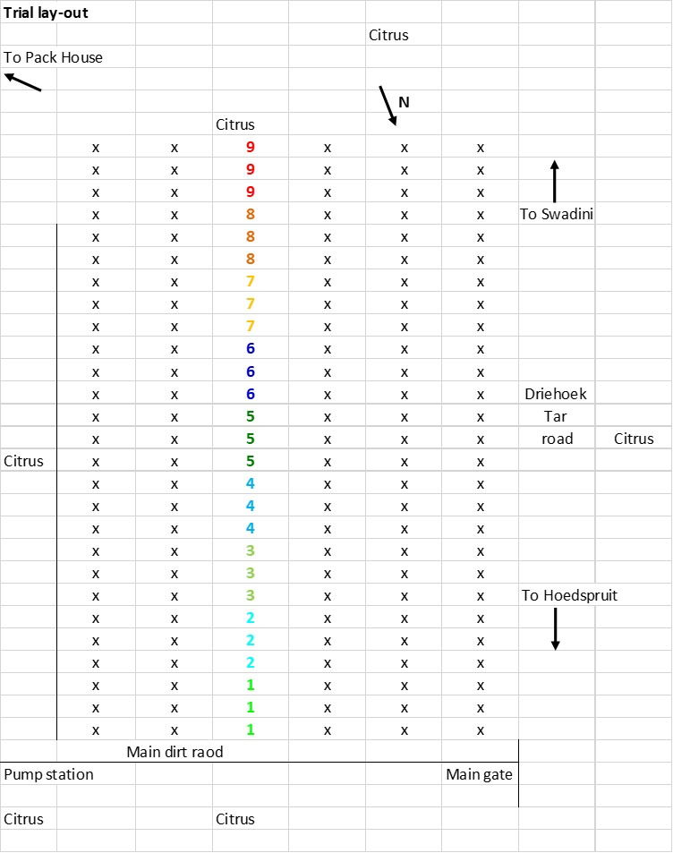

Sep-16-2020 (EL Suncrops Citrus-001) ARM 2020.1 Graphs
Estelle Louw
Evaluate the effect of Suncrops Plus for Sunburn control in citrus.
Trial ID: | EL Suncrops Citrus-001 | Location: | Hoedspruit | Trial Year: | 2019
Protocol ID: | Suncrops Citrus | Investigator: | Estelle Louw
Project ID: |  | Study Director: | Thys van Lingen
 |  | Sponsor Contact: | Wenkem SA

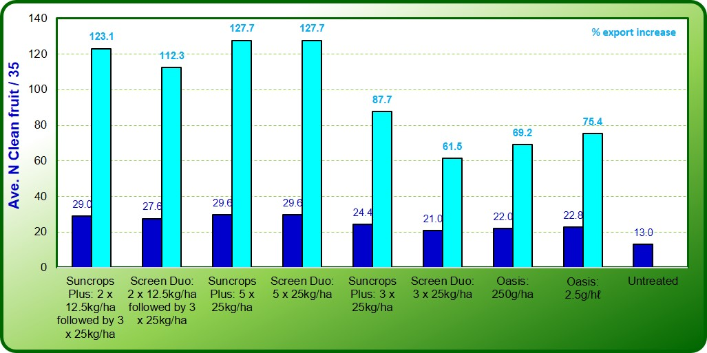

Fig. 7 Average number of fruit free from sunburn damage at 24DAA3 (13.01.2020), i.e. rating 0.

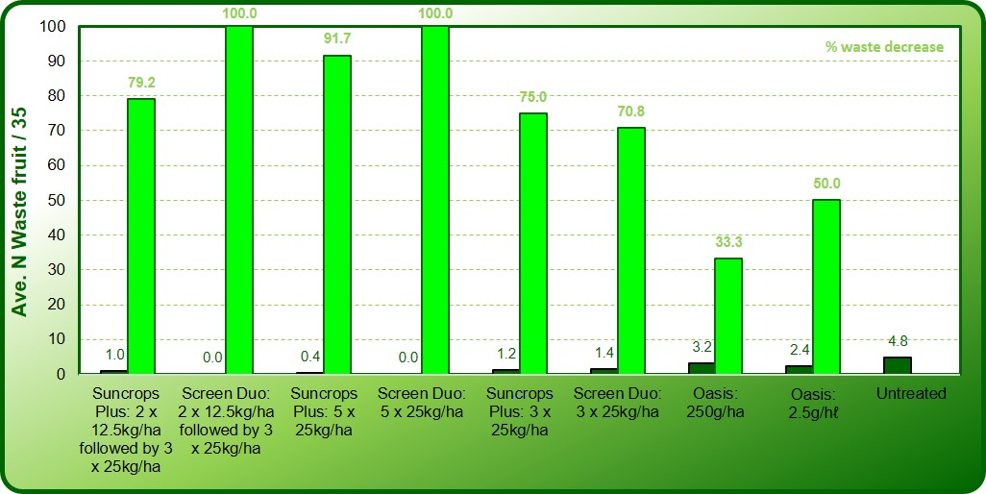

Fig. 8 Average number of fruit with severe sunburn damage at 24DAA3 (13.01.2020), i.e. rating 4 + 5.

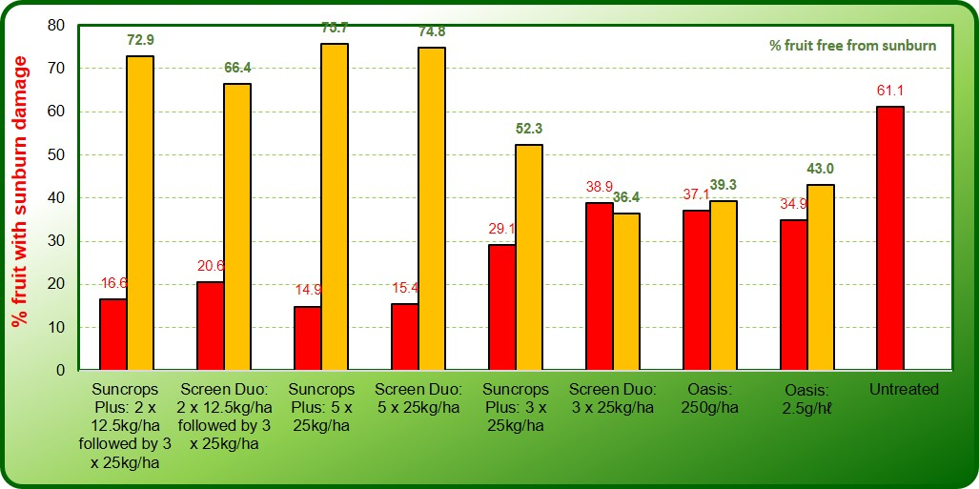

Fig. 9 Mean percentage of fruit with sunburn damage at 24DAA3 (13.01.2020).

Sep-16-2020 (EL Suncrops Citrus-001) ARM 2020.1 Graphs
Estelle Louw
Evaluate the effect of Suncrops Plus for Sunburn control in citrus.
Trial ID: | EL Suncrops Citrus-001 | Location: | Hoedspruit | Trial Year: | 2019
Protocol ID: | Suncrops Citrus | Investigator: | Estelle Louw
Project ID: |  | Study Director: | Thys van Lingen
 |  | Sponsor Contact: | Wenkem SA

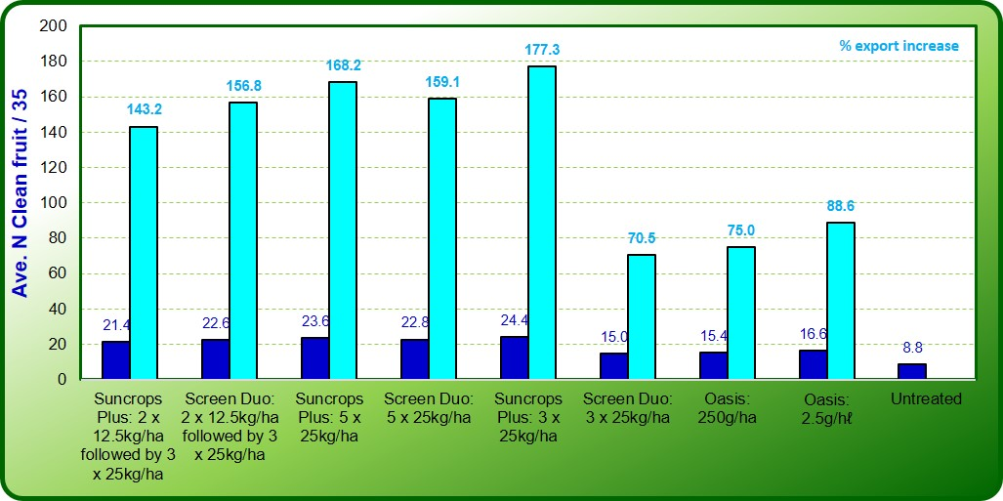

Fig. 10 Average number of fruit free from sunburn damage at 21DAA4 (03.02.2020), i.e. rating 0.

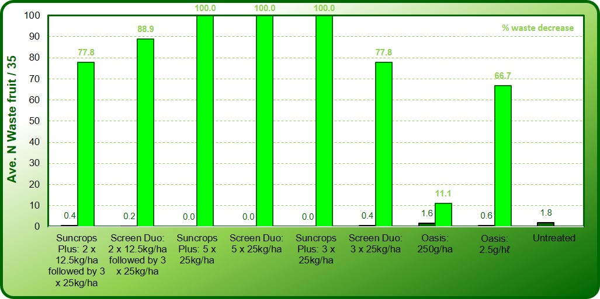

Fig. 11 Average number of fruit with severe sunburn damage at 21DAA4 (03.02.2020), i.e. rating 4 + 5.

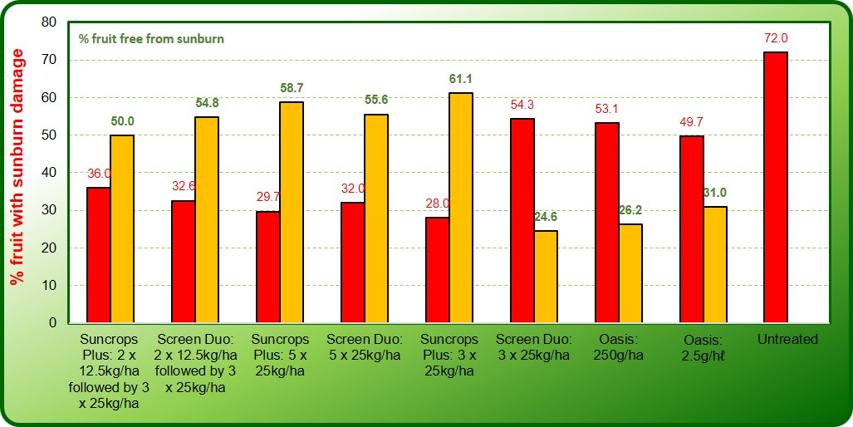

Fig. 12 Mean percentage of fruit with sunburn damage at 21DAA4 (03.02.2020).

Sep-16-2020 (EL Suncrops Citrus-001) ARM 2020.1 Graphs
Estelle Louw
Evaluate the effect of Suncrops Plus for Sunburn control in citrus.
Trial ID: | EL Suncrops Citrus-001 | Location: | Hoedspruit | Trial Year: | 2019
Protocol ID: | Suncrops Citrus | Investigator: | Estelle Louw
Project ID: |  | Study Director: | Thys van Lingen
 |  | Sponsor Contact: | Wenkem SA

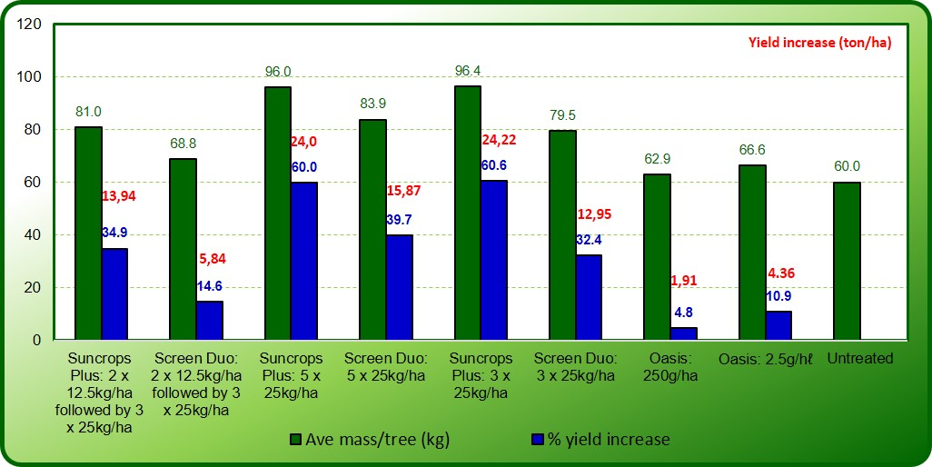

Fig. 13 Yields obtained and percentage yield increase at harvest (21.07.2020).

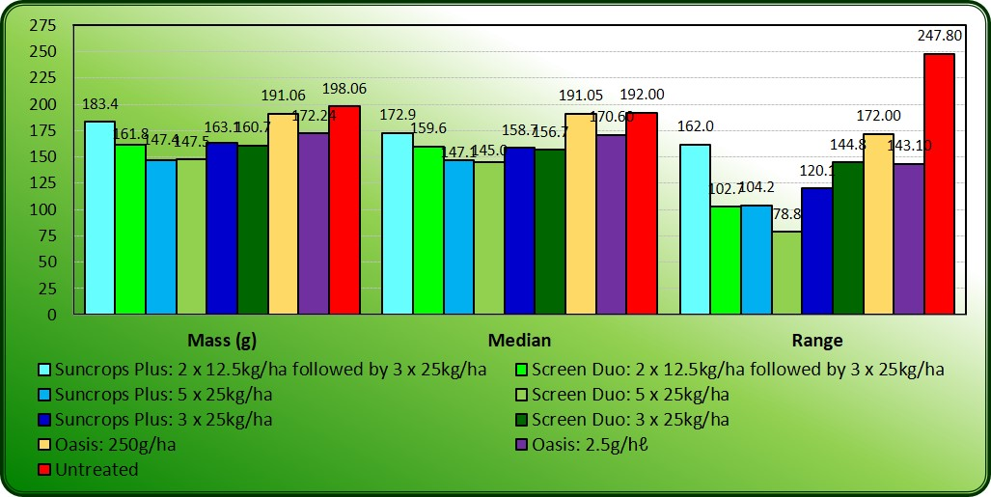

Fig. 14 Average fruit mass obtained post-harvest (31.07.2020).

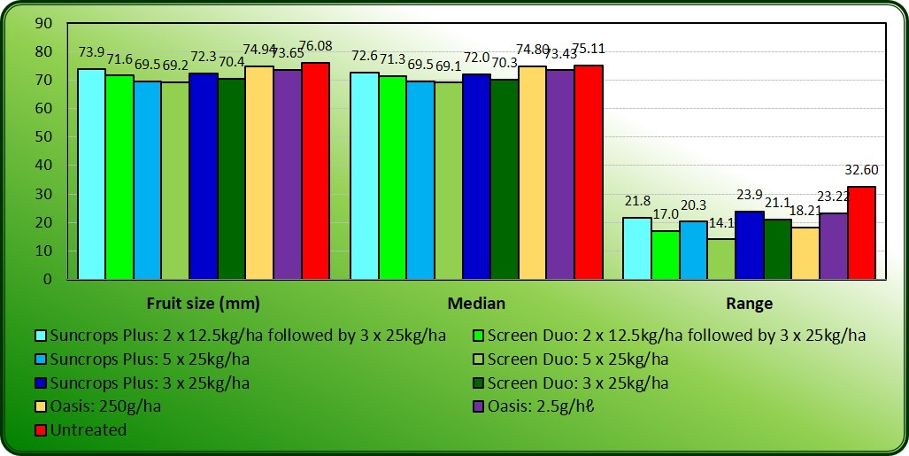

Fig. 15 Average fruit diameter obtained post-harvest (31.07.2020).

Sep-16-2020 (EL Suncrops Citrus-001) ARM 2020.1 Graphs
Estelle Louw
Evaluate the effect of Suncrops Plus for Sunburn control in citrus.
Trial ID: | EL Suncrops Citrus-001 | Location: | Hoedspruit | Trial Year: | 2019
Protocol ID: | Suncrops Citrus | Investigator: | Estelle Louw
Project ID: |  | Study Director: | Thys van Lingen
 |  | Sponsor Contact: | Wenkem SA

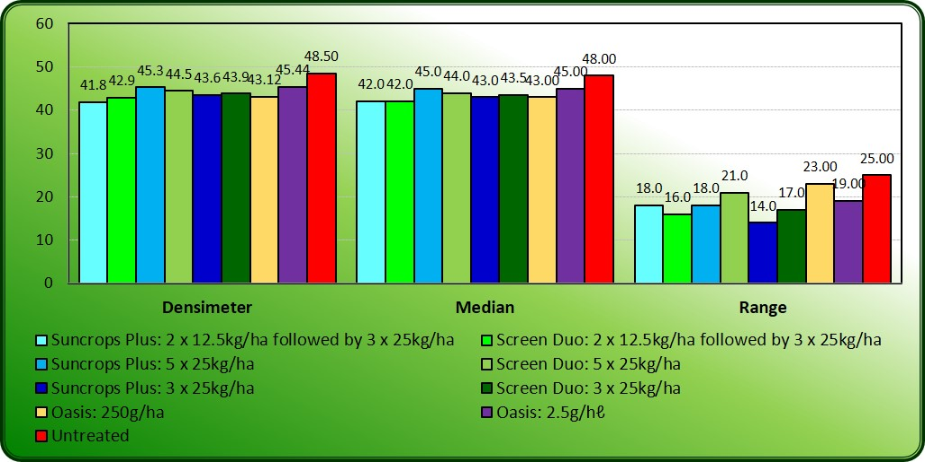

Fig. 16 Fruit firmness (ripeness) as determined post-harvest (31.07.2020).

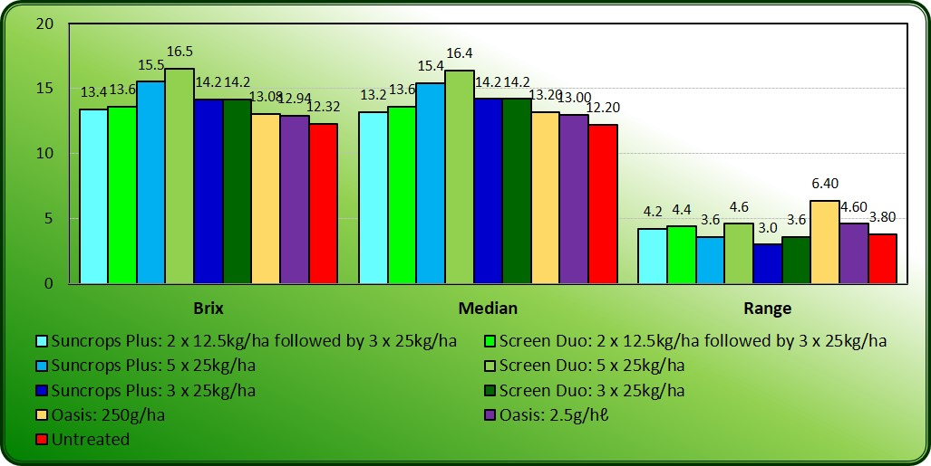

Fig. 17 Fruit brix (sugar content) as determined post-harvest (31.07.2020).

Sep-16-2020 (EL Suncrops Citrus-001) ARM 2020.1 AOV Means Table
Estelle Louw
Evaluate the effect of Suncrops Plus for Sunburn control in citrus.
Trial ID: | EL Suncrops Citrus-001 | Location: | Hoedspruit | Trial Year: | 2019
Protocol ID: | Suncrops Citrus | Investigator: | Estelle Louw
Project ID: |  | Study Director: | Thys van Lingen
 |  | Sponsor Contact: | Wenkem SA

Pest Name |  |  |  |  | Sunburn |  | Sunburn |  | Sunburn |  | Sunburn
Crop Type, Code |  |  |  |  | C CIDSS |  | C CIDSS |  | C CIDSS |  | C CIDSS |  | C CIDSS
Crop Scientific Name |  |  |  |  | Citrus sp. |  | Citrus sp. |  | Citrus sp. |  | Citrus sp. |  | Citrus sp.
Crop Name |  |  |  |  | Citrus |  | Citrus |  | Citrus |  | Citrus |  | Citrus
Crop Variety |  |  |  |  | IRM2 |  | IRM2 |  | IRM2 |  | IRM2 |  | IRM2
Description |  |  |  |  | Severity |  | Severity |  | Incidence |  | Incidence |  | Yield
Rating Date |  |  |  |  | Jan-13-2020 |  | Feb-3-2020 |  | Jan-13-2020 |  | Feb-3-2020 |  | Jul-21-2020
Part Rated |  |  |  |  | FRUIT C |  | FRUIT C |  | FRUIT C |  | FRUIT C |  | YIELD C
Rating Type |  |  |  |  | SCALE |  | SCALE |  | PESINC |  | PESINC |  | WEIGHT
Rating Unit |  |  |  |  | 0-5 |  | 0-5 |  | % |  | % |  | kg/ha
Sample Size |  |  |  |  | 35 FRUIT |  | 35 FRUIT |  | 1 PLOT |  | 1 PLOT |  | 1 PLOT
Collection Basis |  |  |  |  | 1 TREE |  | 1 TREE |  | 1 PLOT |  | 1 PLOT |  | 1 PLOT
Reporting Basis |  |  |  |  | 1 TREATM |  | 1 TREATM |  | 1 TREATM |  | 1 TREATM |  | 1 TREATM
Assessed By |  |  |  |  | E. Louw |  | E. Louw |  | E. Louw |  | E. Louw |  | E. Louw
Days After First/Last Applic. |  |  |  |  | 66 24 |  | 87 21 |  | 66 24 |  | 87 21 |  | 256 169
Trt-Eval Interval |  |  |  |  | 24 DA-C |  | 21 DA-D |  | 24 DA-C |  | 21 DA-D |  | 169 DA-E
Trt | Treatment |  | Rate | Appl
No. | Name | Rate | Unit | Code | 1 |  | 2 |  | 3 |  | 4 |  | 5
1 | Suncrops Plus | 12.5 | kg/ha | AB | 0,39 | cd | 0,73 | b-e | 16,57 | cd | 36,00 | bc | 80,95 | abc
 | Suncrops Plus | 25 | kg/ha | CDE
2 | Screen Duo | 12.5 | kg/ha | AB | 0,40 | cd | 0,63 | cde | 20,57 | bcd | 32,57 | bc | 68,79 | bc
 | Screen Duo | 25 | kg/ha | CDE
3 | Suncrops Plus | 25 | kg/ha | ABCDE | 0,27 | d | 0,61 | de | 14,86 | d | 29,72 | c | 96,02 | a
4 | Screen Duo | 25 | kg/ha | ABCDE | 0,24 | d | 0,58 | e | 15,43 | d | 32,00 | bc | 83,86 | ab
5 | Suncrops Plus | 25 | kg/ha | CDE | 0,58 | bcd | 0,45 | e | 29,15 | bcd | 28,00 | c | 96,39 | a
6 | Screen Duo | 25 | kg/ha | CDE | 0,94 | b | 1,13 | bc | 38,86 | b | 54,28 | ab | 79,47 | abc
7 | Oasis | 250 | g/ha | ABCDE | 1,02 | b | 1,23 | b | 37,14 | b | 53,14 | ab | 62,89 | bc
8 | Oasis | 2,5 | g/100 l | ABCDE | 0,87 | bc | 1,11 | bcd | 34,86 | bc | 49,71 | abc | 66,58 | bc
9 | Untreated Check |  |  |  | 1,55 | a | 1,81 | a | 61,14 | a | 72,00 | a | 60,03 | c
LSD P=.05 |  |  |  |  | 0,529 |  | 0,506 |  | 18,496 |  | 22,582 |  | 22,598
Standard Deviation |  |  |  |  | 0,410 |  | 0,393 |  | 14,357 |  | 17,529 |  | 17,541
CV |  |  |  |  | 59,03 |  | 42,7 |  | 48,11 |  | 40,72 |  | 22,72
Levene's F |  |  |  |  | 1,258 |  | 0,387 |  | 1,193 |  | 0,312 |  | 1,898
Levene's Prob(F) |  |  |  |  | 0,296 |  | 0,92 |  | 0,331 |  | 0,956 |  | 0,091
Skewness |  |  |  |  | 1,2518* |  | 0,5613 |  | 0,9231* |  | -0,0158 |  | 0,1424
Kurtosis |  |  |  |  | 1,2376 |  | 0,0166 |  | 0,1304 |  | -0,7342 |  | 0,211
Replicate F |  |  |  |  | 3,152 |  | 4,908 |  | 2,332 |  | 4,528 |  | 0,885
Replicate Prob(F) |  |  |  |  | 0,0272 |  | 0,0034 |  | 0,0770 |  | 0,0052 |  | 0,4838
Treatment F |  |  |  |  | 5,602 |  | 6,153 |  | 5,561 |  | 3,654 |  | 2,984
Treatment Prob(F) |  |  |  |  | 0,0002 |  | 0,0001 |  | 0,0002 |  | 0,0040 |  | 0,0129

Sep-16-2020 (EL Suncrops Citrus-001) ARM 2020.1 AOV Means Table
Estelle Louw
Evaluate the effect of Suncrops Plus for Sunburn control in citrus.
Trial ID: | EL Suncrops Citrus-001 | Location: | Hoedspruit | Trial Year: | 2019
Protocol ID: | Suncrops Citrus | Investigator: | Estelle Louw
Project ID: |  | Study Director: | Thys van Lingen
 |  | Sponsor Contact: | Wenkem SA
Crop Type, Code
C = EPPO species (Bayer) codes
CIDSS, BCIT, Citrus sp., Citrus = US
Part Rated
FRUIT = fruit
YIELD = yield
C = Crop is Part Rated
Rating Type
PESINC = pest incidence
WEIGHT = weight
Rating Unit
0-5 = 0-5 index/scale|INDEX
% = percent
kg/ha = kilograms per hectare|WEIGHT

FRUIT = fruit
PLOT = total plot

TREE = tree
PLOT = total plot

TREATM = treatment
Assessed By
E. Louw = Estelle Louw

Additional Treatment Information
Rate Unit
kg/ha = Kilograms Dry Product per Hectare (US=kg/A)|
g/ha = Grams Dry Product per Hectare (US=g/A)|
g/100 L = Grams Dry Product per 100 Liters Mix (US=g/100 GAL)|EQ
Sep-16-2020 (EL Suncrops Citrus-001) ARM 2020.1 Assessment Data Summary
Estelle Louw
Evaluate the effect of Suncrops Plus for Sunburn control in citrus.
Trial ID: | EL Suncrops Citrus-001 | Location: | Hoedspruit | Trial Year: | 2019
Protocol ID: | Suncrops Citrus | Investigator: | Estelle Louw
Project ID: |  | Study Director: | Thys van Lingen
 |  | Sponsor Contact: | Wenkem SA

Pest Name |  |  |  |  |  | Sunburn | Sunburn | Sunburn | Sunburn
Crop Type, Code |  |  |  |  |  | C CIDSS | C CIDSS | C CIDSS | C CIDSS | C CIDSS
Crop Scientific Name |  |  |  |  |  | Citrus sp. | Citrus sp. | Citrus sp. | Citrus sp. | Citrus sp.
Crop Name |  |  |  |  |  | Citrus | Citrus | Citrus | Citrus | Citrus
Crop Variety |  |  |  |  |  | IRM2 | IRM2 | IRM2 | IRM2 | IRM2
Description |  |  |  |  |  | Severity | Severity | Incidence | Incidence | Yield
Rating Date |  |  |  |  |  | Jan-13-2020 | Feb-3-2020 | Jan-13-2020 | Feb-3-2020 | Jul-21-2020
Part Rated |  |  |  |  |  | FRUIT C | FRUIT C | FRUIT C | FRUIT C | YIELD C
Rating Type |  |  |  |  |  | SCALE | SCALE | PESINC | PESINC | WEIGHT
Rating Unit |  |  |  |  |  | 0-5 | 0-5 | % | % | kg/ha
Sample Size |  |  |  |  |  | 35 FRUIT | 35 FRUIT | 1 PLOT | 1 PLOT | 1 PLOT
Collection Basis |  |  |  |  |  | 1 TREE | 1 TREE | 1 PLOT | 1 PLOT | 1 PLOT
Reporting Basis |  |  |  |  |  | 1 TREATM | 1 TREATM | 1 TREATM | 1 TREATM | 1 TREATM
Assessed By |  |  |  |  |  | E. Louw | E. Louw | E. Louw | E. Louw | E. Louw
Days After First/Last Applic. |  |  |  |  |  | 66 24 | 87 21 | 66 24 | 87 21 | 256 169
Trt-Eval Interval |  |  |  |  |  | 24 DA-C | 21 DA-D | 24 DA-C | 21 DA-D | 169 DA-E
Trt | Treatment |  | Rate | Appl
No. | Name | Rate | Unit | Code | Plot | 1 | 2 | 3 | 4 | 5
1 | Suncrops Plus | 12.5 | kg/ha | AB | 101 | 0,41 | 0,00 | 14,29 | 0,00 | 83,50
 | Suncrops Plus | 25 | kg/ha | CDE | 209 | 0,97 | 0,71 | 37,14 | 37,14 | 77,90
 |  |  |  |  | 305 | 0,38 | 0,68 | 20,00 | 34,29 | 89,07
 |  |  |  |  | 403 | 0,15 | 0,91 | 8,57 | 42,86 | 82,49
 |  |  |  |  | 506 | 0,03 | 1,35 | 2,86 | 65,71 | 71,80
Mean = |  |  |  |  |  | 0,39 | 0,73 | 16,57 | 36,00 | 80,95
2 | Screen Duo | 12.5 | kg/ha | AB | 102 | 0,56 | 0,65 | 31,43 | 34,29 | 65,11
 | Screen Duo | 25 | kg/ha | CDE | 208 | 0,21 | 0,50 | 11,43 | 22,86 | 62,42
 |  |  |  |  | 306 | 0,59 | 0,59 | 28,57 | 28,57 | 62,97
 |  |  |  |  | 408 | 0,09 | 0,97 | 5,71 | 51,43 | 81,97
 |  |  |  |  | 501 | 0,56 | 0,44 | 25,71 | 25,71 | 71,48
Mean = |  |  |  |  |  | 0,40 | 0,63 | 20,57 | 32,57 | 68,79
3 | Suncrops Plus | 25 | kg/ha | ABCDE | 103 | 0,26 | 0,53 | 14,29 | 22,86 | 114,37
 |  |  |  |  | 207 | 0,06 | 0,50 | 5,71 | 20,00 | 106,47
 |  |  |  |  | 302 | 0,18 | 0,03 | 8,57 | 2,86 | 91,71
 |  |  |  |  | 401 | 0,50 | 0,79 | 25,71 | 51,43 | 87,12
 |  |  |  |  | 508 | 0,35 | 1,21 | 20,00 | 51,43 | 80,41
Mean = |  |  |  |  |  | 0,27 | 0,61 | 14,86 | 29,72 | 96,02
4 | Screen Duo | 25 | kg/ha | ABCDE | 104 | 0,21 | 0,03 | 14,29 | 2,86 | 60,96
 |  |  |  |  | 206 | 0,32 | 1,18 | 17,14 | 65,71 | 93,18
 |  |  |  |  | 304 | 0,24 | 0,12 | 14,29 | 11,43 | 79,52
 |  |  |  |  | 407 | 0,09 | 0,53 | 8,57 | 28,57 | 81,30
 |  |  |  |  | 504 | 0,35 | 1,03 | 22,86 | 51,43 | 104,35
Mean = |  |  |  |  |  | 0,24 | 0,58 | 15,43 | 32,00 | 83,86
5 | Suncrops Plus | 25 | kg/ha | CDE | 105 | 0,35 | 0,00 | 22,86 | 0,00 | 97,77
 |  |  |  |  | 205 | 0,44 | 0,68 | 34,29 | 48,57 | 113,32
 |  |  |  |  | 303 | 1,15 | 0,41 | 42,86 | 25,71 | 126,96
 |  |  |  |  | 409 | 0,18 | 0,18 | 14,29 | 17,14 | 70,73
 |  |  |  |  | 502 | 0,76 | 1,00 | 31,43 | 48,57 | 73,18
Mean = |  |  |  |  |  | 0,58 | 0,45 | 29,15 | 28,00 | 96,39
6 | Screen Duo | 25 | kg/ha | CDE | 106 | 0,35 | 1,32 | 20,00 | 57,14 | 62,95
 |  |  |  |  | 204 | 1,09 | 0,91 | 37,14 | 51,43 | 80,48
 |  |  |  |  | 309 | 0,71 | 0,62 | 28,57 | 20,00 | 86,74
 |  |  |  |  | 406 | 0,91 | 1,06 | 42,86 | 65,71 | 108,55
 |  |  |  |  | 509 | 1,62 | 1,76 | 65,71 | 77,14 | 58,65
Mean = |  |  |  |  |  | 0,94 | 1,13 | 38,86 | 54,28 | 79,47
7 | Oasis | 250 | g/ha | ABCDE | 107 | 0,09 | 0,32 | 5,71 | 28,57 | 46,98
 |  |  |  |  | 203 | 0,74 | 2,15 | 20,00 | 80,00 | 56,01
 |  |  |  |  | 301 | 1,62 | 1,12 | 62,86 | 40,00 | 26,59
 |  |  |  |  | 405 | 1,65 | 1,38 | 60,00 | 68,57 | 92,56
 |  |  |  |  | 503 | 1,00 | 1,18 | 37,14 | 48,57 | 92,30
Mean = |  |  |  |  |  | 1,02 | 1,23 | 37,14 | 53,14 | 62,89
8 | Oasis | 2,5 | g/100 l | ABCDE | 108 | 0,44 | 0,88 | 20,00 | 34,29 | 62,85
 |  |  |  |  | 202 | 0,41 | 0,59 | 20,00 | 25,71 | 62,24
 |  |  |  |  | 308 | 1,15 | 0,91 | 37,14 | 62,86 | 62,17
 |  |  |  |  | 404 | 0,53 | 1,71 | 28,57 | 65,71 | 78,57
 |  |  |  |  | 507 | 1,82 | 1,44 | 68,57 | 60,00 | 67,07
Mean = |  |  |  |  |  | 0,87 | 1,11 | 34,86 | 49,71 | 66,58

Sep-16-2020 (EL Suncrops Citrus-001) ARM 2020.1 Assessment Data Summary
Estelle Louw
Evaluate the effect of Suncrops Plus for Sunburn control in citrus.
Trial ID: | EL Suncrops Citrus-001 | Location: | Hoedspruit | Trial Year: | 2019
Protocol ID: | Suncrops Citrus | Investigator: | Estelle Louw
Project ID: |  | Study Director: | Thys van Lingen
 |  | Sponsor Contact: | Wenkem SA

Pest Name |  |  |  |  |  | Sunburn | Sunburn | Sunburn | Sunburn
Crop Type, Code |  |  |  |  |  | C CIDSS | C CIDSS | C CIDSS | C CIDSS | C CIDSS
Crop Scientific Name |  |  |  |  |  | Citrus sp. | Citrus sp. | Citrus sp. | Citrus sp. | Citrus sp.
Crop Name |  |  |  |  |  | Citrus | Citrus | Citrus | Citrus | Citrus
Crop Variety |  |  |  |  |  | IRM2 | IRM2 | IRM2 | IRM2 | IRM2
Description |  |  |  |  |  | Severity | Severity | Incidence | Incidence | Yield
Rating Date |  |  |  |  |  | Jan-13-2020 | Feb-3-2020 | Jan-13-2020 | Feb-3-2020 | Jul-21-2020
Part Rated |  |  |  |  |  | FRUIT C | FRUIT C | FRUIT C | FRUIT C | YIELD C
Rating Type |  |  |  |  |  | SCALE | SCALE | PESINC | PESINC | WEIGHT
Rating Unit |  |  |  |  |  | 0-5 | 0-5 | % | % | kg/ha
Sample Size |  |  |  |  |  | 35 FRUIT | 35 FRUIT | 1 PLOT | 1 PLOT | 1 PLOT
Collection Basis |  |  |  |  |  | 1 TREE | 1 TREE | 1 PLOT | 1 PLOT | 1 PLOT
Reporting Basis |  |  |  |  |  | 1 TREATM | 1 TREATM | 1 TREATM | 1 TREATM | 1 TREATM
Assessed By |  |  |  |  |  | E. Louw | E. Louw | E. Louw | E. Louw | E. Louw
Days After First/Last Applic. |  |  |  |  |  | 66 24 | 87 21 | 66 24 | 87 21 | 256 169
Trt-Eval Interval |  |  |  |  |  | 24 DA-C | 21 DA-D | 24 DA-C | 21 DA-D | 169 DA-E
Trt | Treatment |  | Rate | Appl
No. | Name | Rate | Unit | Code | Plot | 1 | 2 | 3 | 4 | 5
9 | Untreated Check |  |  |  | 109 | 1,06 | 1,50 | 57,14 | 60,00 | 45,95
 |  |  |  |  | 201 | 0,85 | 1,09 | 40,00 | 45,71 | 70,95
 |  |  |  |  | 307 | 1,94 | 1,94 | 77,14 | 88,57 | 45,62
 |  |  |  |  | 402 | 1,35 | 2,09 | 51,43 | 82,86 | 82,78
 |  |  |  |  | 505 | 2,56 | 2,44 | 80,00 | 82,86 | 54,83
Mean = |  |  |  |  |  | 1,55 | 1,81 | 61,14 | 72,00 | 60,03

Sep-16-2020 (EL Suncrops Citrus-001) ARM 2020.1 Assessment Data Summary
Estelle Louw
Evaluate the effect of Suncrops Plus for Sunburn control in citrus.
Trial ID: | EL Suncrops Citrus-001 | Location: | Hoedspruit | Trial Year: | 2019
Protocol ID: | Suncrops Citrus | Investigator: | Estelle Louw
Project ID: |  | Study Director: | Thys van Lingen
 |  | Sponsor Contact: | Wenkem SA

Crop Type, Code
C = EPPO species (Bayer) codes
CIDSS, BCIT, Citrus sp., Citrus = US
Part Rated
FRUIT = fruit
YIELD = yield
C = Crop is Part Rated
Rating Type
PESINC = pest incidence
WEIGHT = weight
Rating Unit
0-5 = 0-5 index/scale|INDEX
% = percent
kg/ha = kilograms per hectare|WEIGHT

FRUIT = fruit
PLOT = total plot

TREE = tree
PLOT = total plot

TREATM = treatment
Assessed By
E. Louw = Estelle Louw

Additional Treatment Information
Rate Unit
kg/ha = Kilograms Dry Product per Hectare (US=kg/A)|
g/ha = Grams Dry Product per Hectare (US=g/A)|
g/100 L = Grams Dry Product per 100 Liters Mix (US=g/100 GAL)|EQ

This is to confirm that this trial was conducted under good agricultural practices. This report is an accurate and true reflection of the trial procedure and results obtained.
Researcher
------------------------------ Date: 17.09.2020
Estelle Louw

Appendix A: Weather conditions: Bavaria Fruit Estate (S24.40250°; E030.88255°; 519.2m)
